Kubernetes Questions:

1.Identify the component which component help to create a container, pull the docker image.

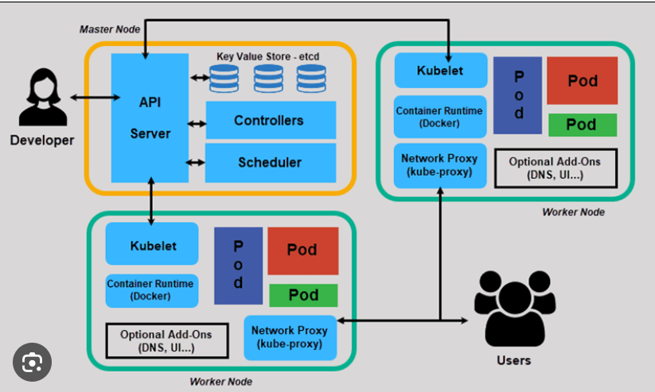

2. Please see the below Deployment Manifest File. Identify what’s going wrong within it.

apiVersion: apps/v1

kind: Deployment

metadata:

name: sample-deployment

labels:

app: python

spec:

replicas: 3

template:

metadata:

labels:

app: python

spec:

containers:

- name: python

image: muralisocial123/python-app-sample:1.0

ports:

- containerPort: 5000

3. Please see the below two images and explain how the scaling happened with command?

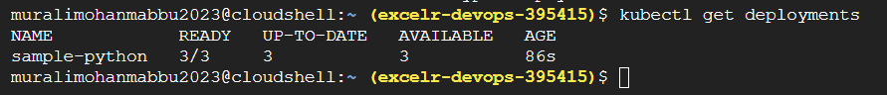



4. Please find the below image and explain how the service created with command?

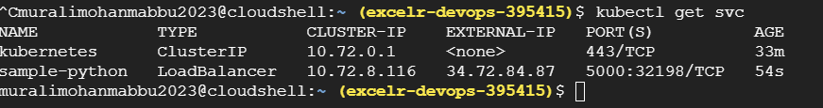

5. **kubectl get events --sort-by=.metadata.creationTimestamp : What is the use of this command and explain with screenshot.**

6. While creating volumes in kubernetes which is mandatory filed do we need to mention while writing manifest file. Please observe the script and explain.

**apiVersion**: v1

**kind**: Pod

**metadata**:

**name**: test-pd

**spec**:

**containers**:

- **image**: muralisocial123/samplepython

**name**: test-container

**volumeMounts**:

- **mountPath**: /test-pd

**name**: test-volume

**volumes**:

- **name**: test-volume

**hostPath**:

**path**: /data

**type**: Directory

7. By looking the below image while creating pod. Pod Status is showing “ErrImagePull”. Please explain why pod is not running.

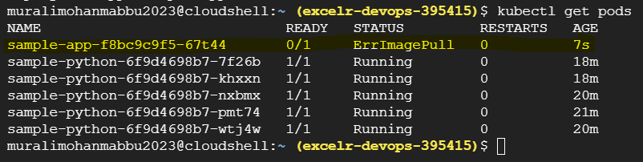

8. Write a Service Manifest file for the Given Deployment and Identify the error?

apiVersion: apps/v1

kind: Deployment

metadata:

name: sample-deployment

labels:

app: python

spec:

replicas: 3

template:

metadata:

labels:

app: python

spec:

containers:

- name: python

image: muralisocial123/python-app-sample:1.0

ports:

- containerPort: 5000

9. See the below command and explain if we change container port number what will happen ?

docker run -td --name webserver -p 80(host):80(container) ubuntu (d-daemon)

10. Why do we want to share the volumes with containers ? what happens If I removed –privilaged=true command.

docker run -it --name mycont2(new) --privileged=true --volumes-from mycont1(old) ubuntu /bin/bash

11. What is the role of the docker demon. How do you create docker demon containers?

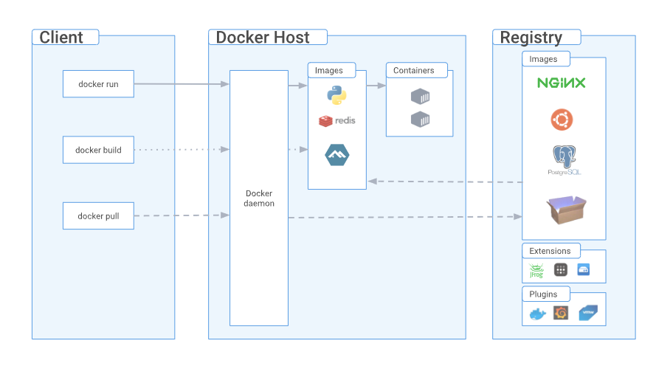

12. How to create a custom docker network. Please see the below image and explain how to deploy container within the custom network.

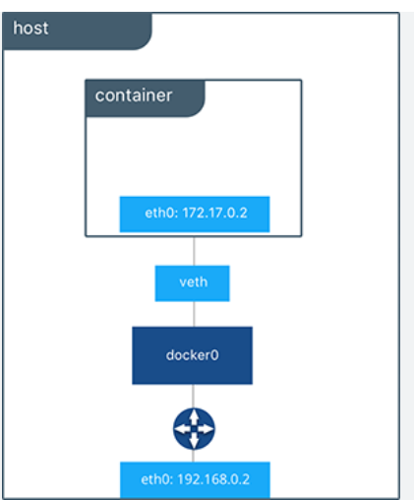

**AWS Questions :**

1. While creating EC2 Instance why do we need configure network settings? If I would to expose the application through the public IP Address which port number do we need to enable?

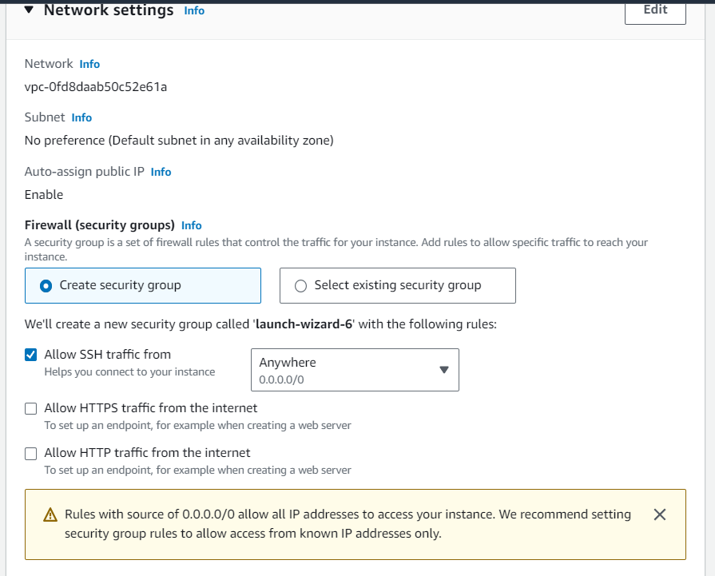

1. See the below image and explain why do we need to user user data while creating instance?

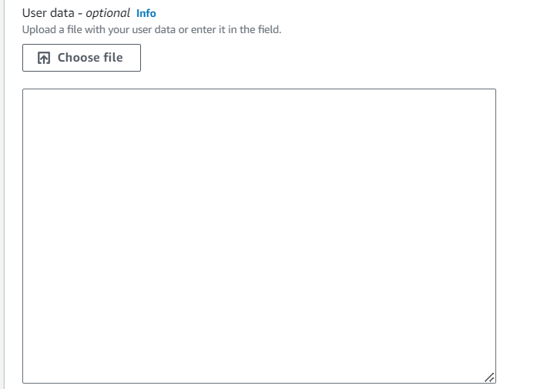

1. Once created Windows EC2 Instance If I would to connect which port number do we need to use? How do you access from windows OS?
2. See the below Image and explain which key pair do we need to select if you want connect instance from Mac OS?

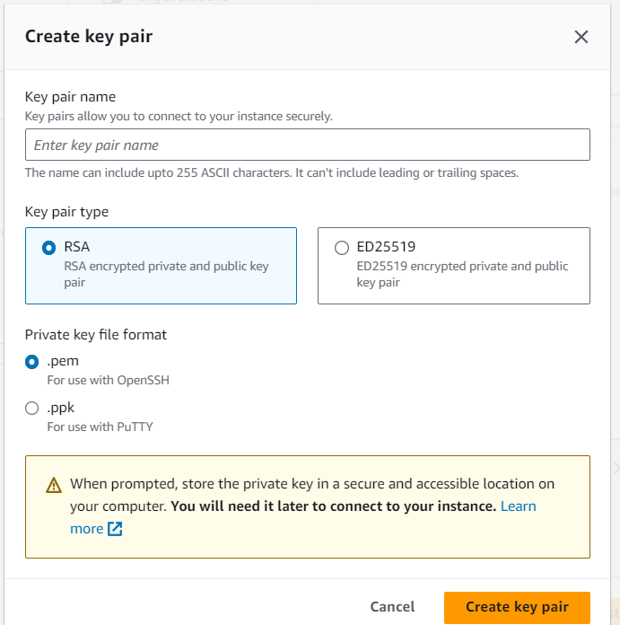

1. While S3 Creating bucket why do we need select Object Ownership? Which one we have to choose?

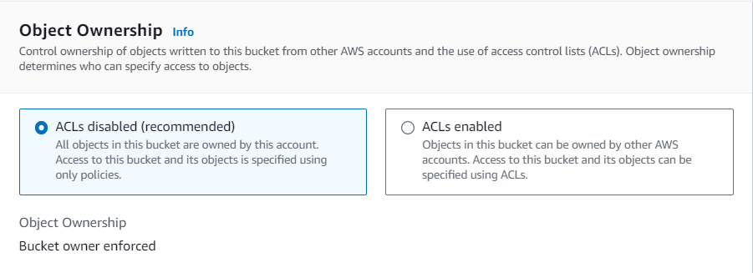

1. Is it Required to enable versioning for all the buckets ? If say Yes How can you Justifying?

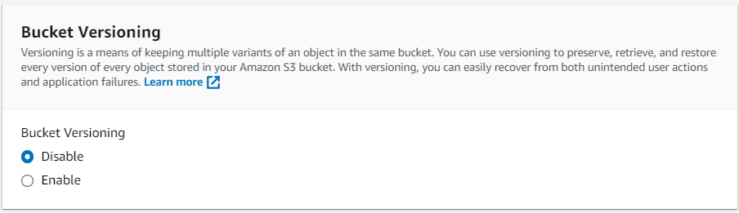

1. See the below Image and suggest which encryption method you are going suggest while creating bucket and why ?

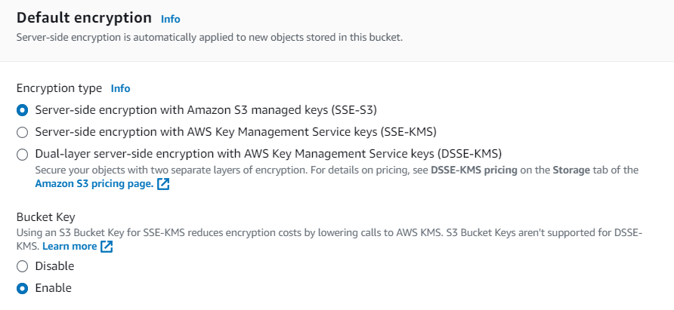

1. If we deleted object once enable the version? Is it possible to restore the object ?

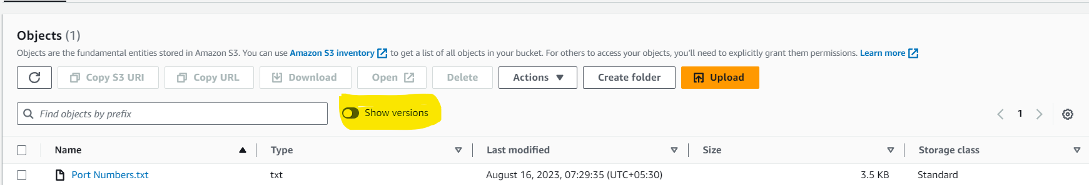

1. While creating VPC Network. How can we decide how many instances we can create within VPC? 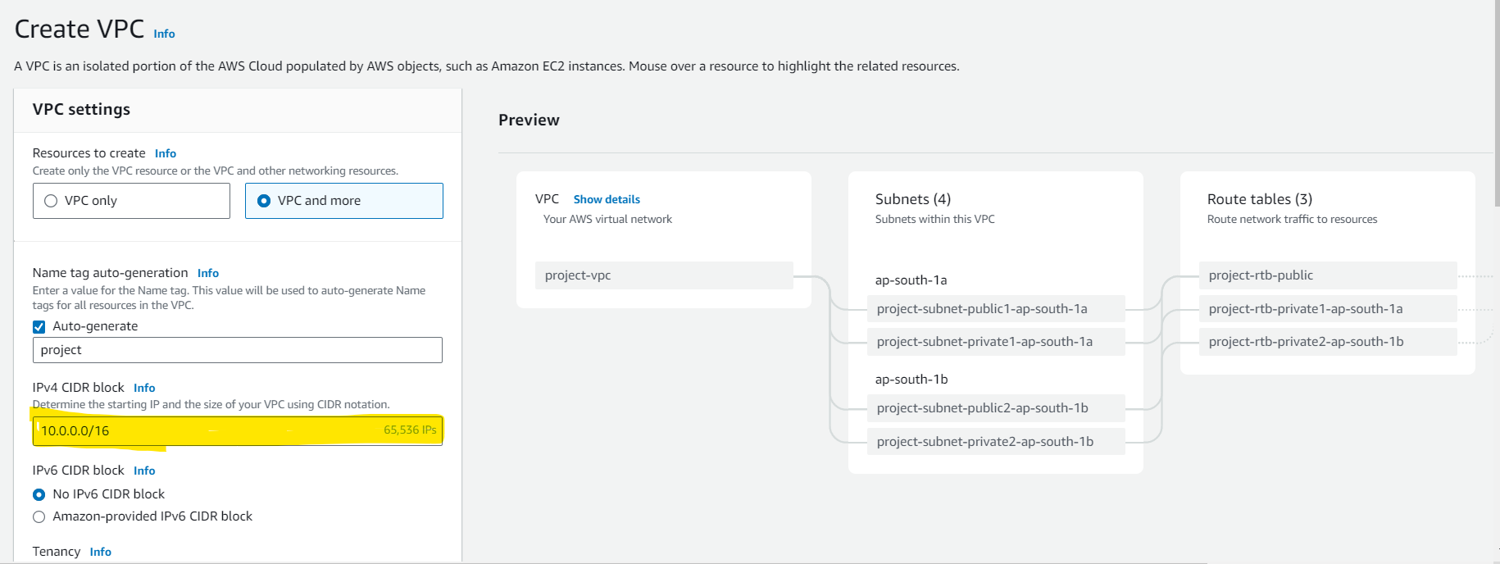
2. While creating VPC Network in CIDR Block Mentioned IP Address Range: 172.10.15.0/32 , If I am creating subnet within VPC If I mentioned subnet IP Address 172.11.15.0 Is it work or do we need to change subnet IP Address?

